Revision Hıstory
Date | Version | Description | Author
07/10/2022 | 1.0 | Determined the project altogether and created the repository on GitHub. | Emir Ulurak
08/10/2022 | 1.1 | Created tables and Gantt Chart on Excel. | Metin Karaca

TABLE OF CONTENTS

Revision History 1
1 Identification 3
1.1 Document overview 3
1.2 Abbreviations 3
1.2.1 Abbreviations 3
1.3 References 3
1.3.1 Project References 3
2 Software Development Activities 3
2.1 Software development process 3
2.1.1 Overview of process phases 3
2.1.2 Technical documentation 4
2.1.3 Deliverables 4
2.2 Software development tools 4
2.2.1 Workstation 4
2.2.2 Requirements management and documentation 4
2.2.3 Software Design 4
2.2.4 Coding and automated tests 4
2.2.5 Configuration management 4
2.3 Software development rules and standards 4
3 Responsibilities 5
3.1 Activities and responsibilities 5
4 Risk Assessment 5
4.1 Risk Analysis 5
4.2 Risk Planning 5

Identification

Document overview

This document contains the software development plan of software Gesture Snake.

Gesture snake is a web-based video game which let the player control the classical snake game with hand gestures.

Abbreviations

Abbreviations

Add here abbreviations. For example, define an abbreviation for the software system that is going to be developed and use this abbreviation to refer to the system in the rest of the document. You can also add other abbreviations that were previously defined. For example, a list like the following one can be provided.

GS: Gesture Snake
XXX: <The name of the software system to be developed>
UML: Unified Modeling Language
IDE: Integrated Development Environment
JDK: Java Development Kit
SRS: Software Requirement Specification
STP: Software Test Plan
SDD: Software Design Document
STR: Software Test Report
…

References

Project References

# | Document Identifier | Document Title
[R1] | StackOverFlow | https://stackoverflow.com/
[R2] | OpenCV | https://docs.opencv.org/4.x/d6/d00/tutorial_py_root.html

Software Development Activities

The section lists and describes the software development activities of GS software development project.

Software development process

This is a course project, which adopts the waterfall model as the software development process.

Overview of process phases

The software development process for the project will be composed of the following phases:
- Planning
- Requirements Analysis
- Design
- Implementation
- Testing and Analysis

These phases will follow each other sequentially, where each phase starts just after the completion of the previous one. The following Gantt chart depicts the planned start date and duration for the phases.

Include a Gantt chart here!

Technical documentation

The following documentation is produced during the software development phases:
- Software specification: SRS, STP
- Software detailed conception: SDD
- Software tests phases: STR
- Software analysis: SAR

Deliverables

The following items will be delivered at the end of the process:
- Technical documentation as outlined in Section 2.1.2
- Software and its configuration files

Software development tools

Workstation
Baris: Apple MacBook Air M1 16GB
Efe: Monster Notebook I7 9750H 8GB
Emir: Apple MacBook Air M1 16GB
Emre:
Etkin: Asus TUF I7 11370 16GB
Metin: Apple MacBook Pro M1 PRO 16GB

Requirements management and documentation
Microsoft Word, Google Sheets, Microsoft Excel.

Software Design

Describe tools used for software design :
- Argo UML open source tool, Microsoft Visio, Rational Rose, Together J, etc.

Coding and automated tests
Microsoft Visual Studio Code,
IntelliJ with Maven,
Junit tests,
Sublime Text,
Docker

Configuration management
GitHub will be used for software configuration management and tracking issues regarding the software development. A public repository will be created for this purpose.

Software development rules and standards
UML will be used for software design documentation.

Describe here other standards and rules you plan to use for software development, if any. For instance, you can follow a particular coding standard/convention (e.g., Oracle provides coding conventions for Java: http://www.oracle.com/technetwork/java/codeconvtoc-136057.html). Then you should mention it here and provide a link for it.

Responsibilities

Activities and responsibilities

Each activity has someone responsible (although multiple project members can be involved in the activity), mandatory.

Activity | Responsibility | Comment
Project management | Emir Ulurak
Configuration tools management | Metin Karaca, Efe Soykan
Setting up the Development tools | Baris Tudes, Emir Ulurak, Efe Soykan, Metin Karaca, Emre Besik, Etkin Kinik
Database design | Etkin Kinik, Emre Besik
Game design | Emre Besik, Baris Tudes, Efe Soykan
Testing | Metin Karaca
Controller design | Emir Ulurak, Etkin Kinik

Risk Assessment

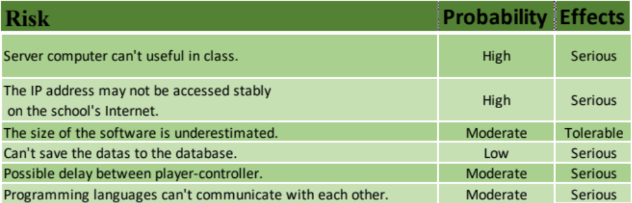Risk Analysis

Risk Planning

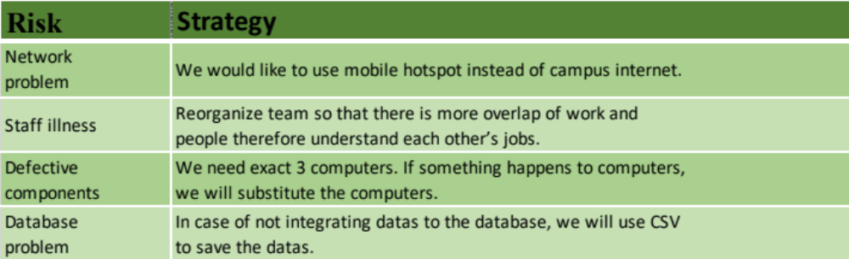

http://www.github.com
http://www.uml.org/

